Hate crime data analysis in USA using TABLEAU visualization software.

Maya Sharma

Department of applied data science, IUPUI, Indianapolis, IN, 46202

Data Source: The data file for analysis is CSV file used here and connected to tableau. It was downloaded from freely available source in github. The link for data is:

<https://github.com/fivethirtyeight/data/>

1. **Which State has the most hate crime?**

According to map its District of Columbia 1.522 per 100k splc.

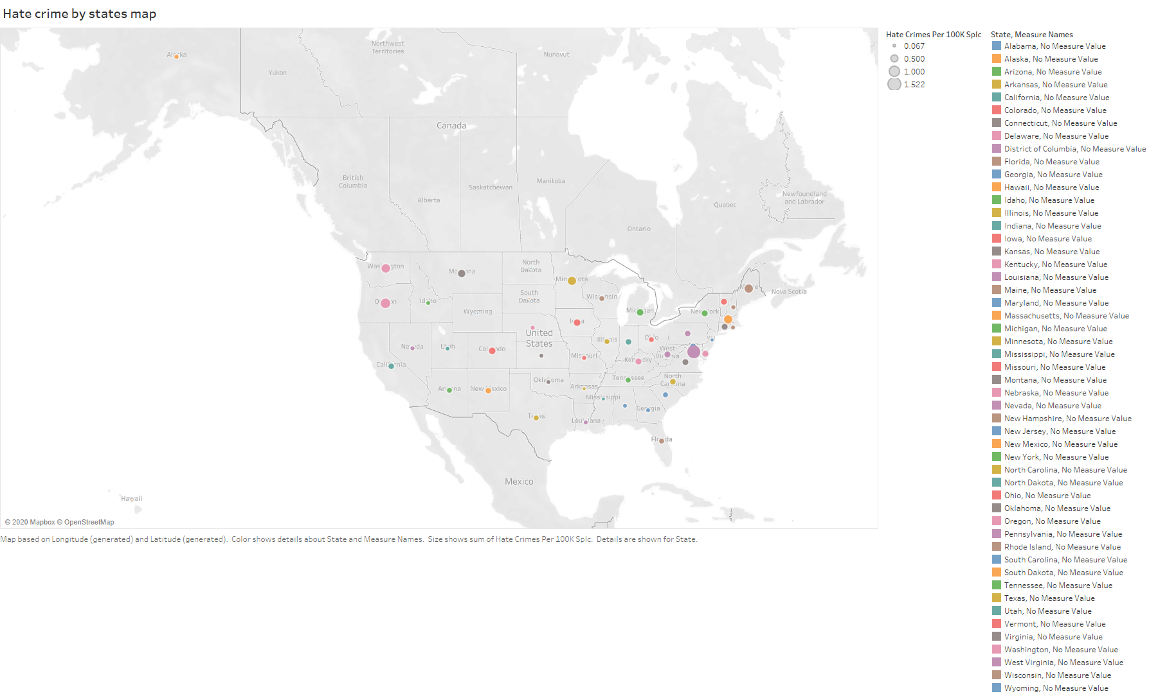

1. **Which state has the highest and lowest hate crime?**

Data submitted by two groups look very different except first two states. The issue here is states with null values (may be missing data or no crime at all). This problem is addressed by using calculation field to convert total of SPLC unit to average in the next workbook.

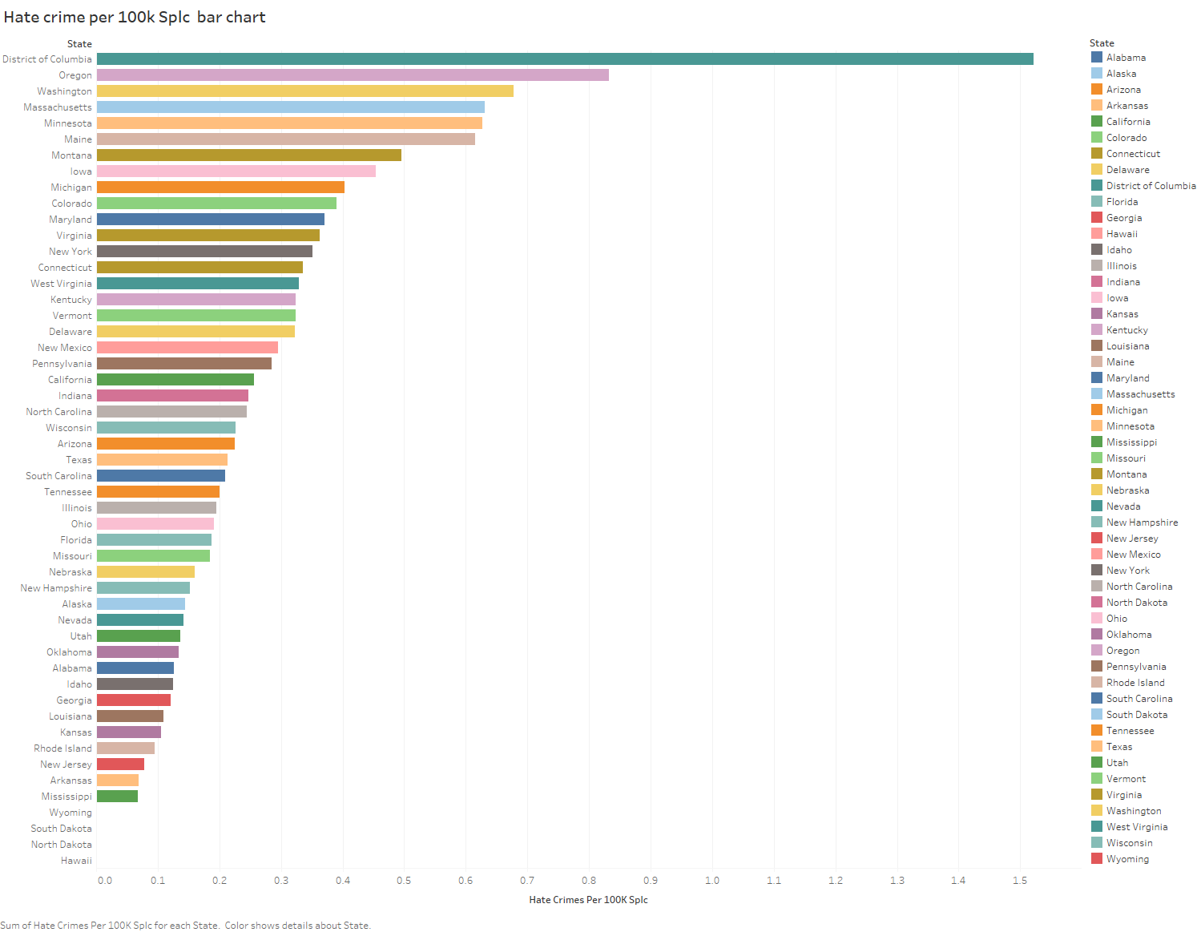

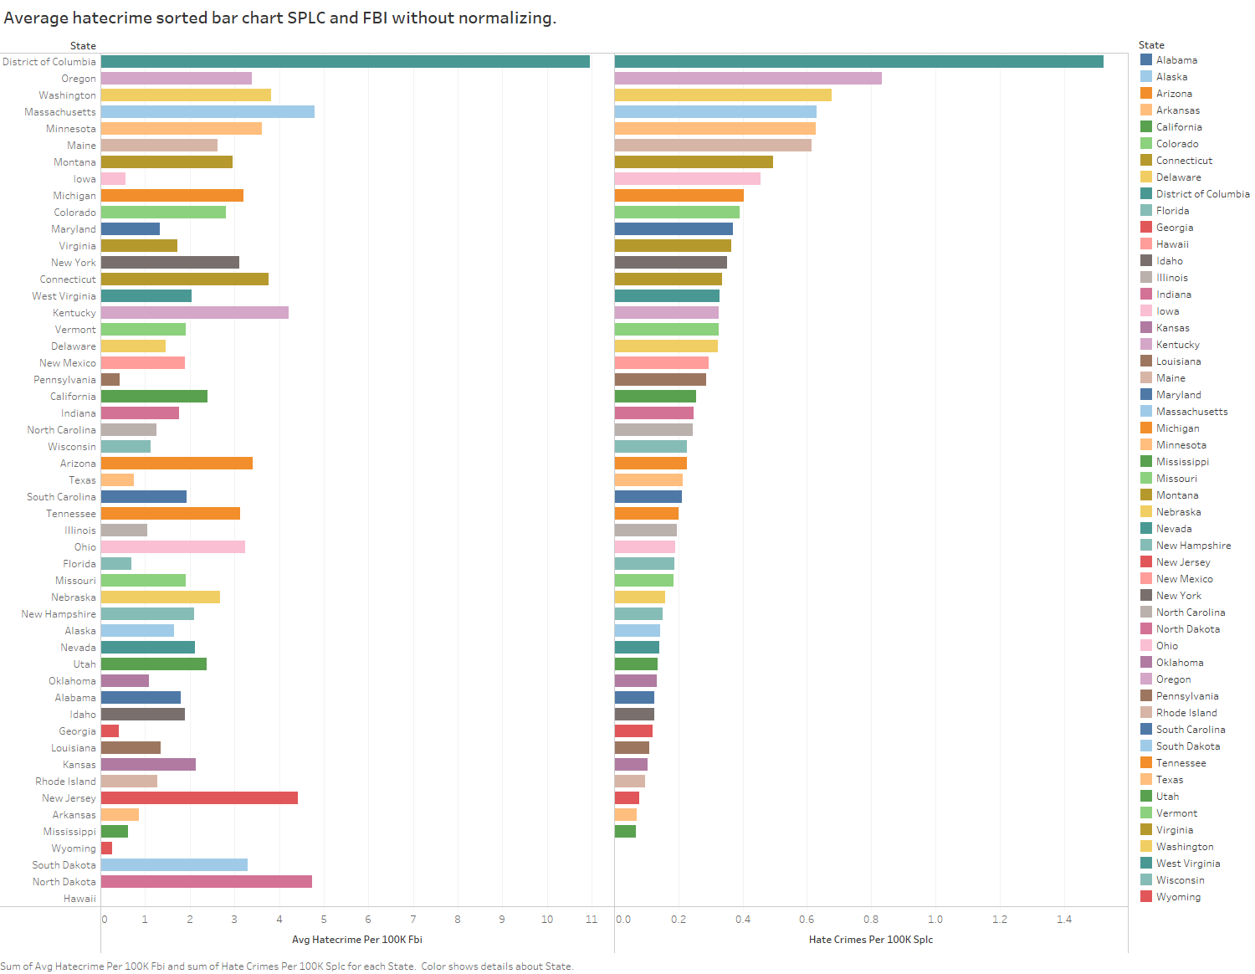

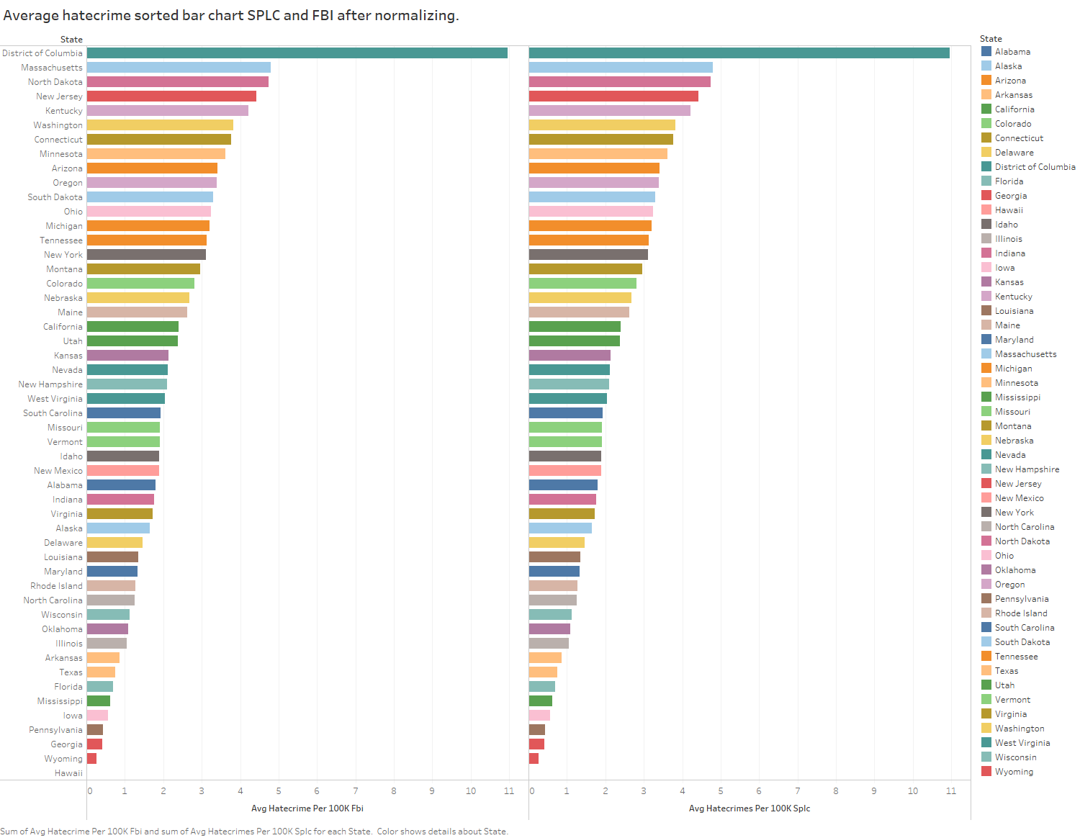

1. **Which state has the most and the least average hate crime in both data group?**

District of Columbia is the highest and Wyoming is the lowest in such crime.

Shared non-citizens.

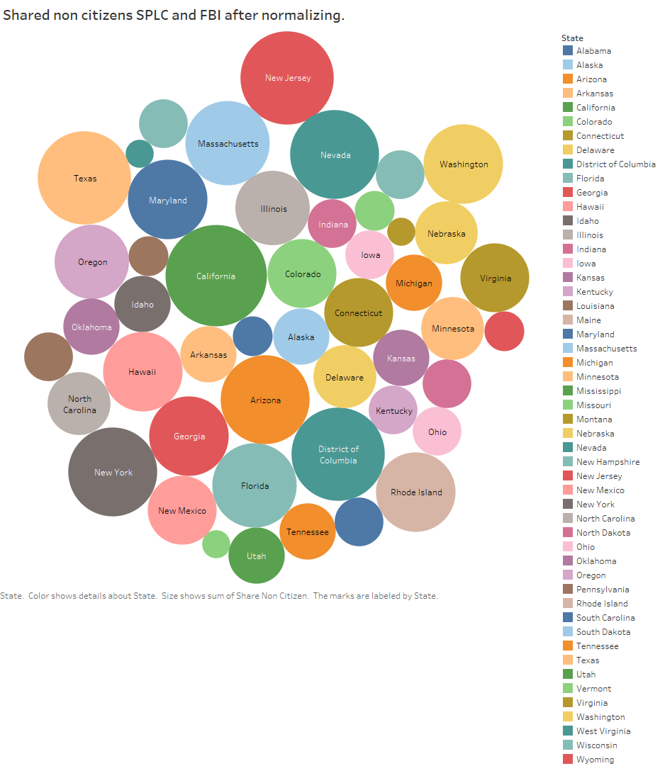

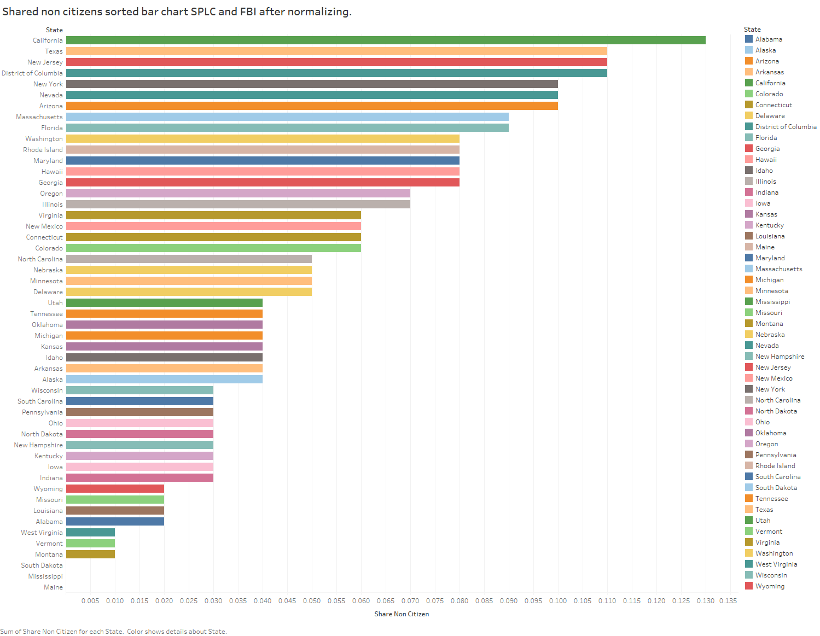

1. **What is non-citizen shared distribution among states?**

California has highest shared non-citizen Texas, New Jersey and District of Columbia are second and Wyoming, Vermont and Montana the least and Dakotas, Mississippi and Maine has no data.

1. **Is this correct way to get the conclusion?**

Answer: NO. It needs further analysis.

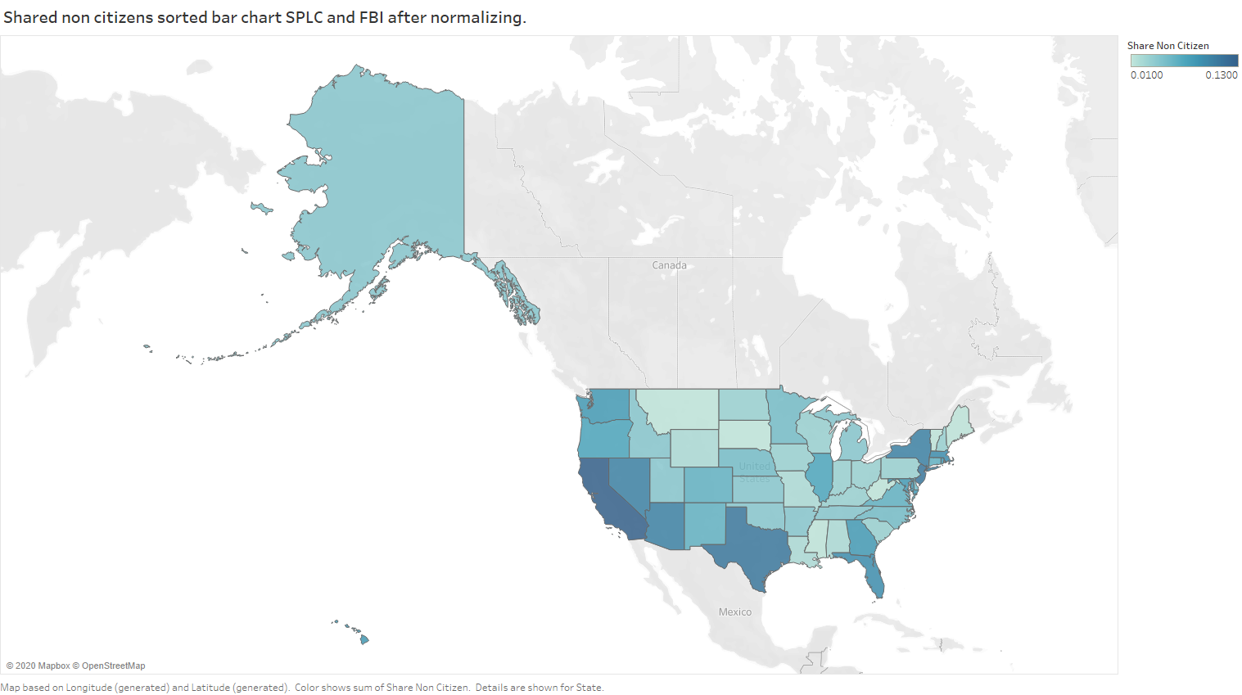

1. Share non- white citizen state?

Hawaii is top, Vermont is bottom, DC, NM and CA are second.

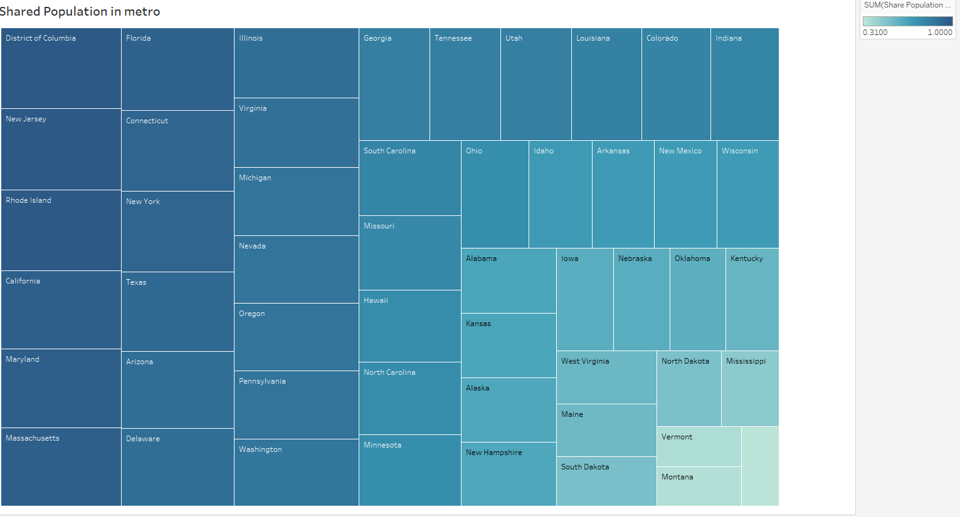

It can be seen that shared trump voter vs crime and shared non-citizens vs crime gives just opposite result which seems obvious.

Visually, it is clear that more trump voters less the hate crime and less trump voters more non-citizen less the hate crime. More shared non-citizens more crime which is expected in hate crime.

District of Columbia stays the same with both conditions as hate crime is the highest always.

1. **Why?** Needs further investigation/analysis so has to closer look into data.
2. **Is there something interesting?**

Definitely, it is interesting that despite of shared trump voters, there

MN and NJ seem somewhat neutral with the respective trend and Delaware and Connecticut too so.

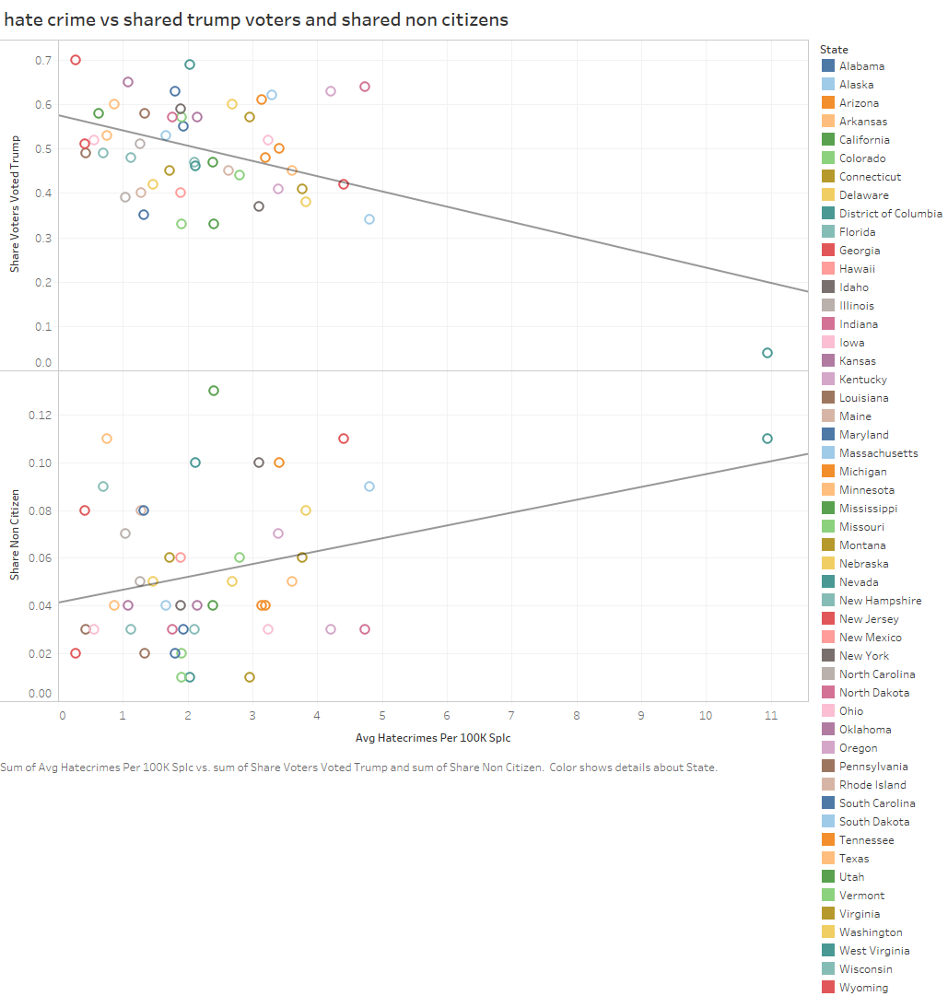

1. Anything interesting in case of white poverty and non-citizen share?

It looks KY has higher hate crime with high white poverty.

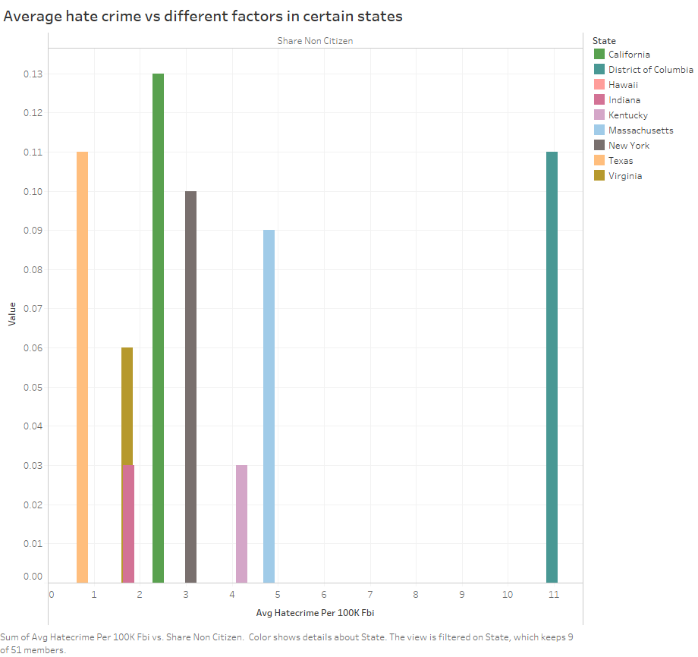

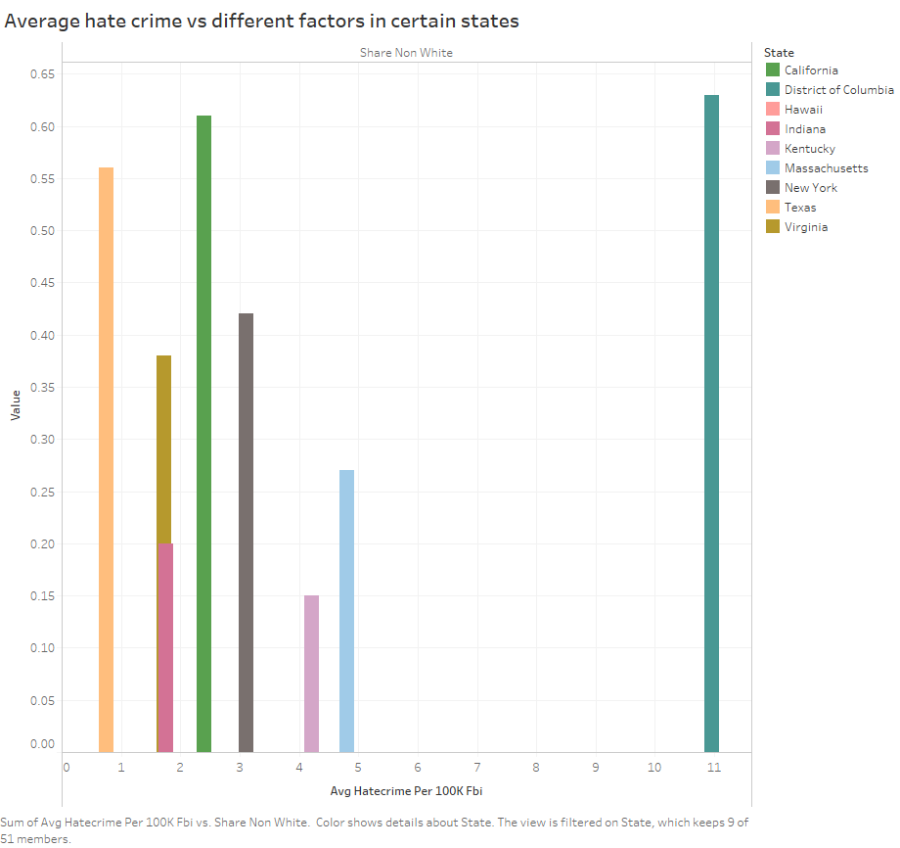

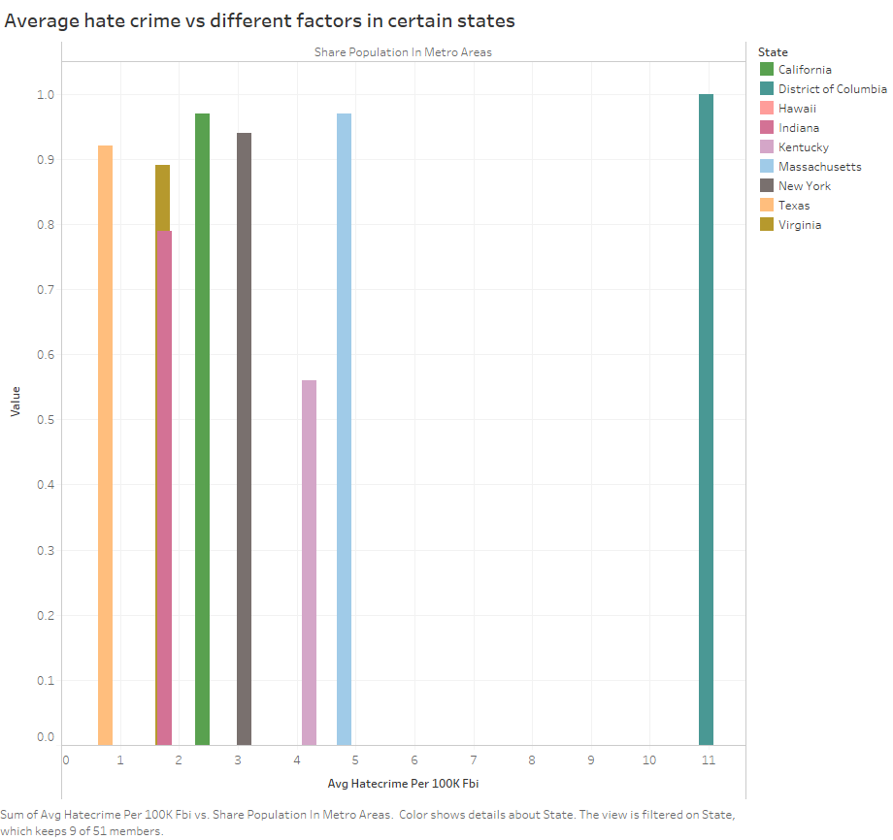

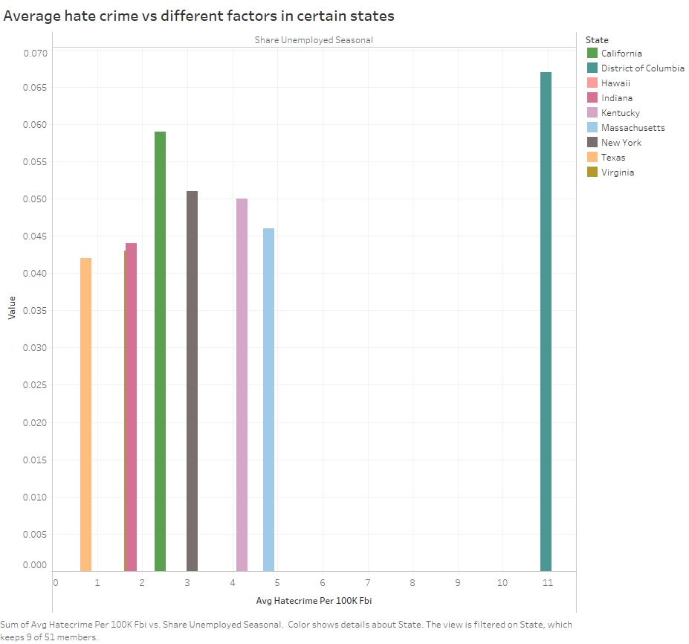

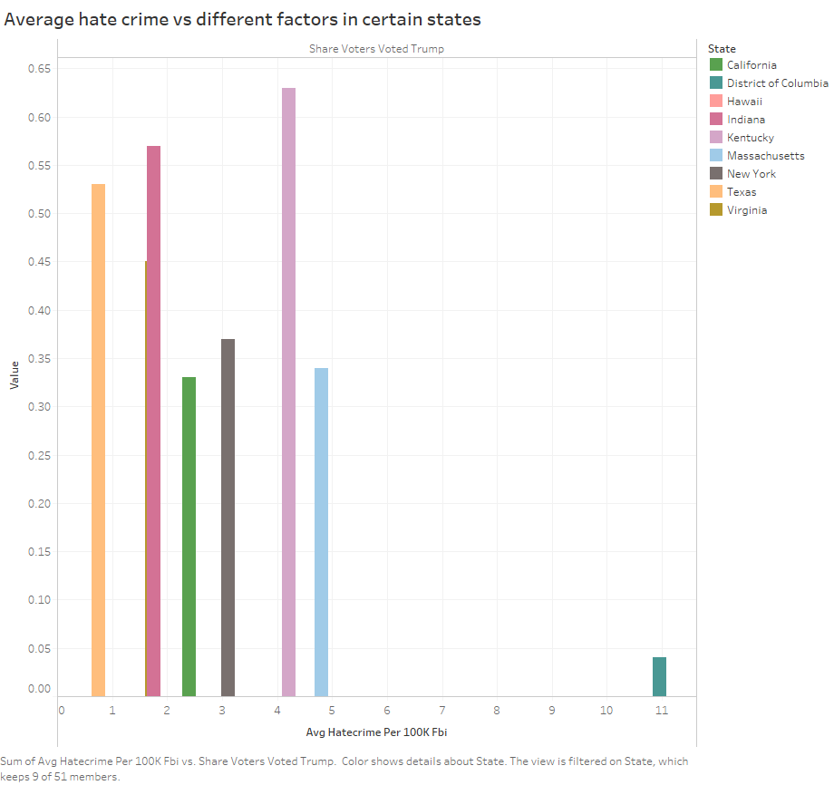

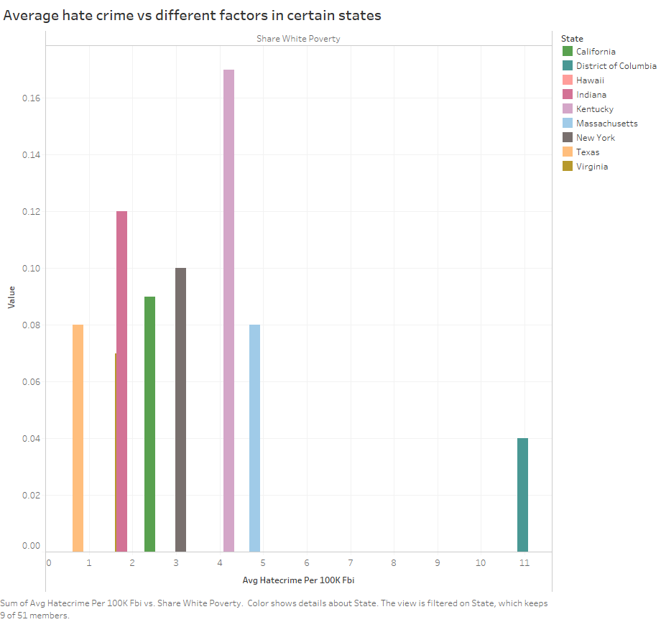

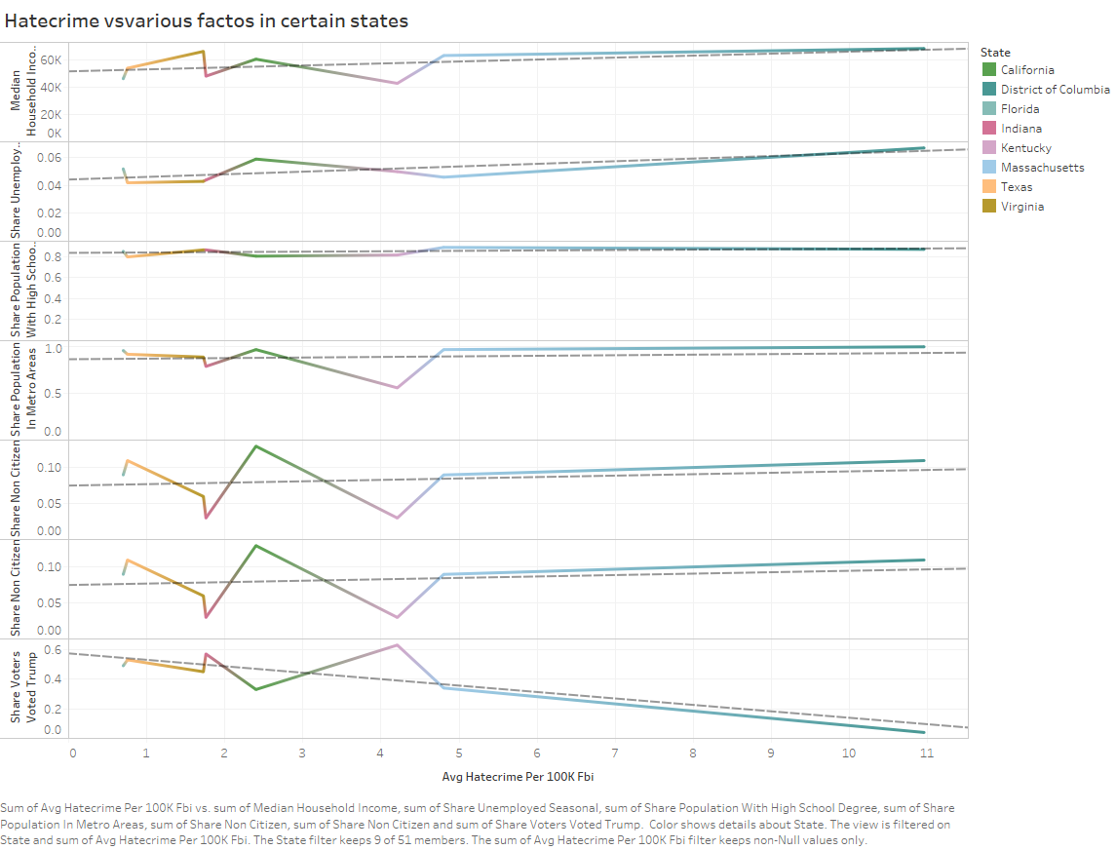

1. Any pattern in average hate crime with non-citizen shared population?

Connecticut state shows neutral increased crime where as other states with high non-citizen (immigrant occupied states) show steady increase in hate crime.

1. Any states which how less hate crime despite of non-citizen share increased?

Yes, Wyoming shows this and the reason may be the number of populations in total is too low there.

1. Interestingly, Vermont, Montana are high in such crime even low non-citizen share which is opposite of trendline according to visualization. Even the rate of hate crime is higher in North Dakota and Kentucky with average non-citizen share.
2. Any interesting result with Trump Voters shares states?

Interestingly with average trump voter shared population in Massachusetts hate crime is the highest but lowest in Pennsylvania.

1. What is the trend of crime with white poverty?

The trend line shows more the white poverty less the hate crime.

New Jersey shows exception in comparison to other similar trend as the hate crime is high there.

1. What is the trend with non-white population shared?

More non-white people more the hate crime but Hawaii is fully non-white majority state so its exception.

1. Is there any concrete conclusion by analyzing data visually?

It was not that easy to draw immediate conclusion looking into the data of all 50 states at once.

Overall trend with exceptions is there due to geography and population distribution among states.

To draw conclusion, subset with Eight states were analyzed separately by visualizing against all the factors provided as columns in data.

The result is drawn as the trend with non-white and non-citizen mix states having high hate crime with some exceptions. Among eight states later analyzed have a very similar trend that despite of various factors the trend is still similar.

Hate crime states from high to low among seven states are MA, KY, NY, CA, IN, VA, TX in which MA is the second top hate crime state even in all fifty states.

District of Columbia is the most exceptionally high hate crime state there out of fifty states.

1. Conclusion: Regardless of factors provided, visualization and analysis show that hate crime is always high when non-citizens and white are mixed or share. This crime even does not exist when there is dominance of only non-citizen or immigrants as seen in only state with zero hate crime is Hawaii. Median income, housing, education etc. to play role in such crime but the main issue is with the non-citizen population distribution.